LIVERPOOL WEST PUBLIC SCHOOL
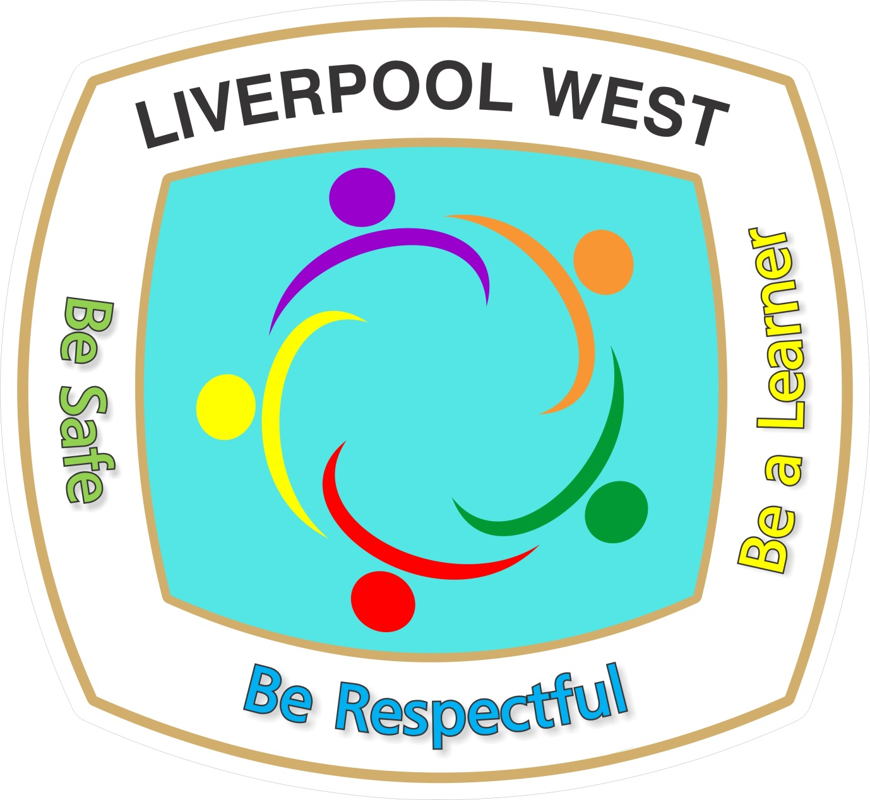
on the land of the Cabrogal People of the Darug Nation
118 Flowerdale Road
LIVERPOOL NSW 2170
Phone: 02 8784 3500
liverpoolw-p.school@det.nsw.edu.au
_________________________________________________
July 2024
Dear Parents/Carers

KINDERGARTEN EXCURSION MONDAY 9 SEPTEMBER 2024

This semester students in kindergarten will be learning about ‘Material World’ in Term 3 and ‘Physical World’ Term 4 in our Science Unit. To support the learning of our students we have organised an excursion to Early Discovery Space, University of Wollongong to further their knowledge of this topic. Students will engage in a range of activities where they will investigate and interact with items that move.

DETAILS:
WHO: Students and teachers from K Blue, K Indigo, K Sapphire, K Teal,
K Navy, K-6 Sky and K-3 Mint
WHEN: Monday 9 September 2024
WHERE: Early Discovery Space, University of Wollongong
HOW: Travel by Bus
TIME: Leave school: 9:00am sharp
(students MUST be at school by 8:45am) Return to school: 3:10pm (approximately)
COST: $30.00 per student
WHAT TO BRING: Crunch n Sip, lunch, fruit break and a bottle of water in a plastic bag labelled with your child’s name and class.
WHAT TO WEAR: Full school uniform and hat.

Please sign and return the permission note and money by
Wednesday 21 August 2024.

MRS McCARRON AND THE KINDERGARTEN TEACHERS LUCY MARTIN
Principal
===========================================================================
PERMISSION NOTE

I give permission for my child………………………………………………………….….………… in class………………………..……… to participate in the educational excursion to The Early Discovery Space, University of Wollongong on Monday 9 September 2024. I understand the children will be travelling by bus and the cost is $30.00 per student.

In the event of illness or injury I authorise the accompanying teachers to get medical assistance on my behalf.

MEDICARE NUMBER: …………………………………………………………………………..
CONTACT NUMBERS: (Mobile):……………………………………………………….. (Home):……………………………….…………..

SIGNED:…………………………………………………………………………… DATE:……………..………………......
(Parent/Carer)

