LIVERPOOL WEST PUBLIC SCHOOL
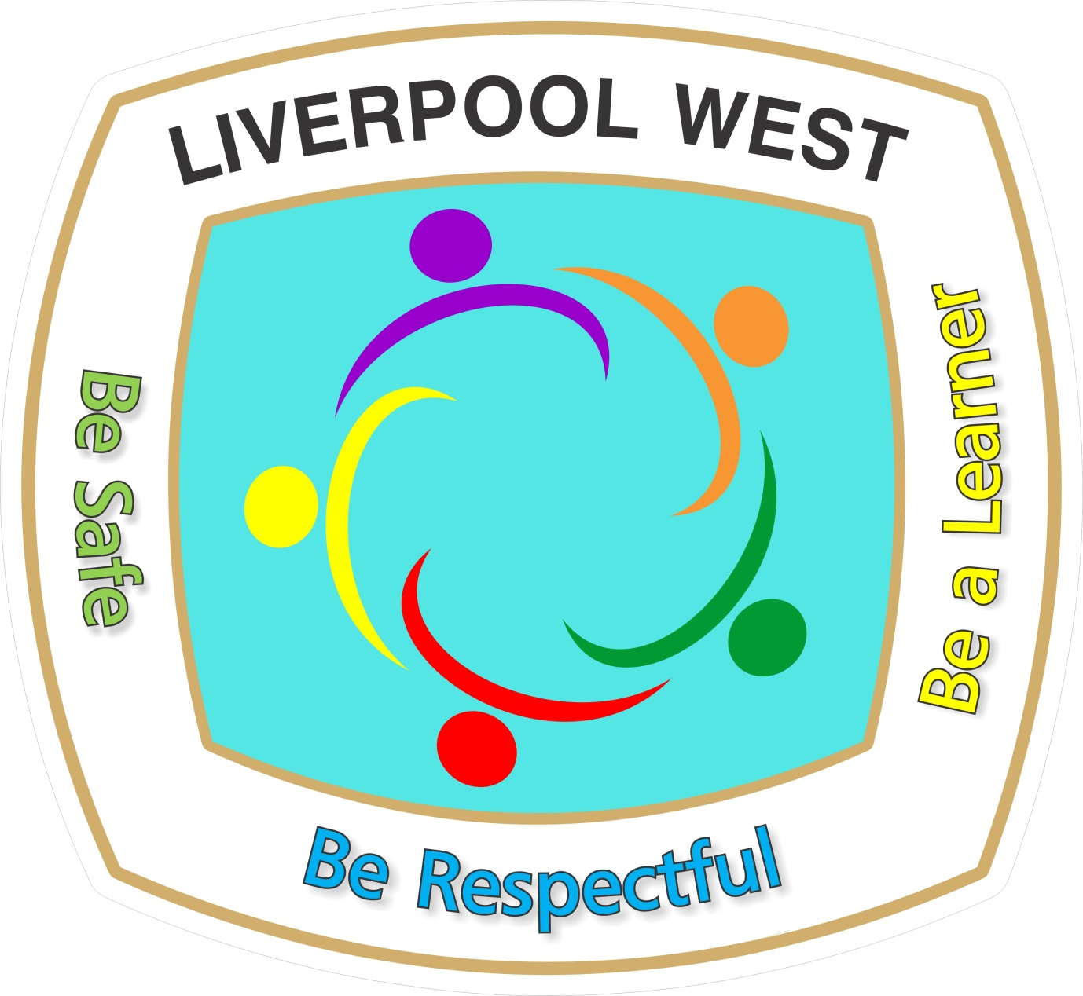
on the land of the Cabrogal People of the Darug Nation
118 Flowerdale Road
LIVERPOOL NSW 2170
Phone: 02 8784 3500
liverpoolw-p.school@det.nsw.edu.au
_________________________________________________

Special Religious Education
A feature of the public education system in NSW is the opportunity to provide time in class for education in ethics, faith and morality from a religious or non-religious perspective at the choice of parents/carers.
The school website (https://liverpoolw-p.schools.nsw.gov.au/) provides information on the options available at Liverpool West Public School to support parent/carer choice.
A parent/carer may, at any time, notify the school in writing that they wish to change their decision. Students will continue the same arrangement as the previous year unless a parent/carer has requested a change in writing.
If your preferred Special Religious Education option is not available, please contact the approved provider. Students not attending Special Religious Education are given supervised alternative meaningful activities.
For more information about Special Religious Education, including the list of approved providers, please visit: https://education.nsw.gov.au/religion-and-ethics.
The following options are available at Liverpool West Public School. Please choose one.
Special Religious Education options:
- Option 1: Anglican
- Option 2: Catholic
- Option 3: Islamic
If you do not wish for your child to attend Special Religious Education, please select below:
- Gulyangarri (for Aboriginal students ONLY)
- alternative meaningful activities.
Student name: Class:
Name of parent/carer: Date:
Signature of parent/carer:

If you selected Special Religious Education, you confirm that, in doing so, you consent to the Department of Education providing your child’s name to the nominated approved provider. The department is required to obtain your consent under Section 26 of the Privacy and Personal Information Protection Act 1998 (NSW) so that it does not have to comply with Section 19, which would otherwise apply to prevent the department from providing your child’s name.

